**Exercise 2: E-commerce Platform Search Function**

Product.java

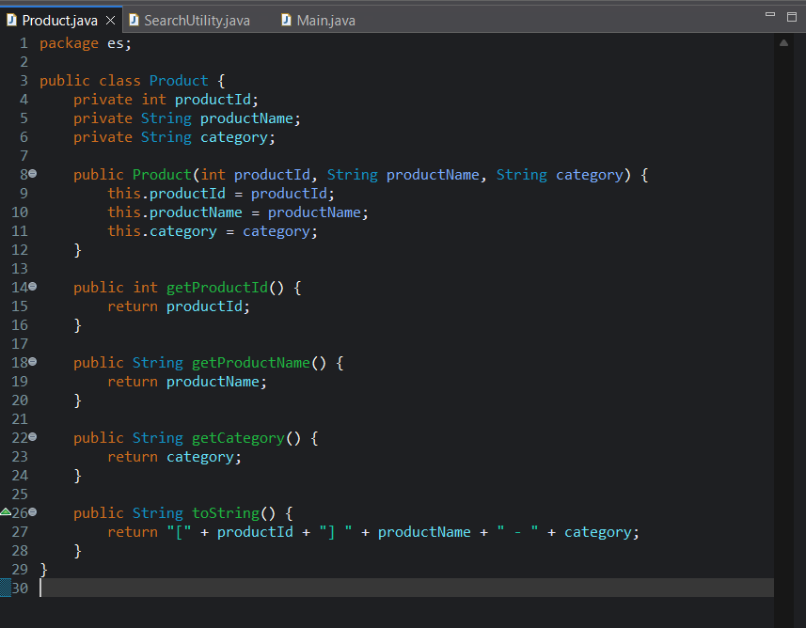

SearchUtility.java

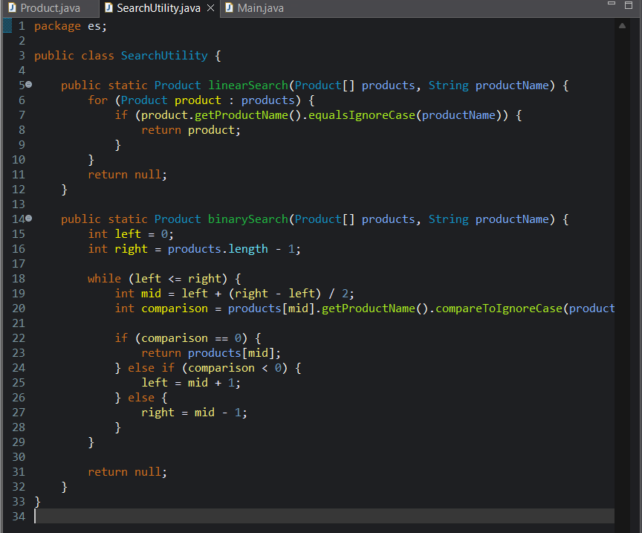

Main.java

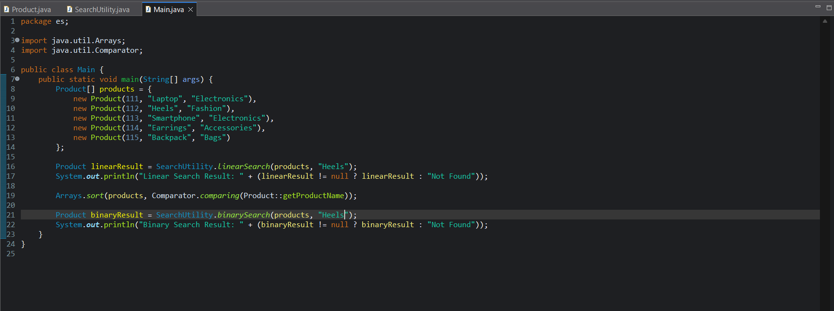

**Output**:   
  
